VOLUNTEER’S STAFFING FORM FOR 2019 NEWARK BEER FESTIVAL 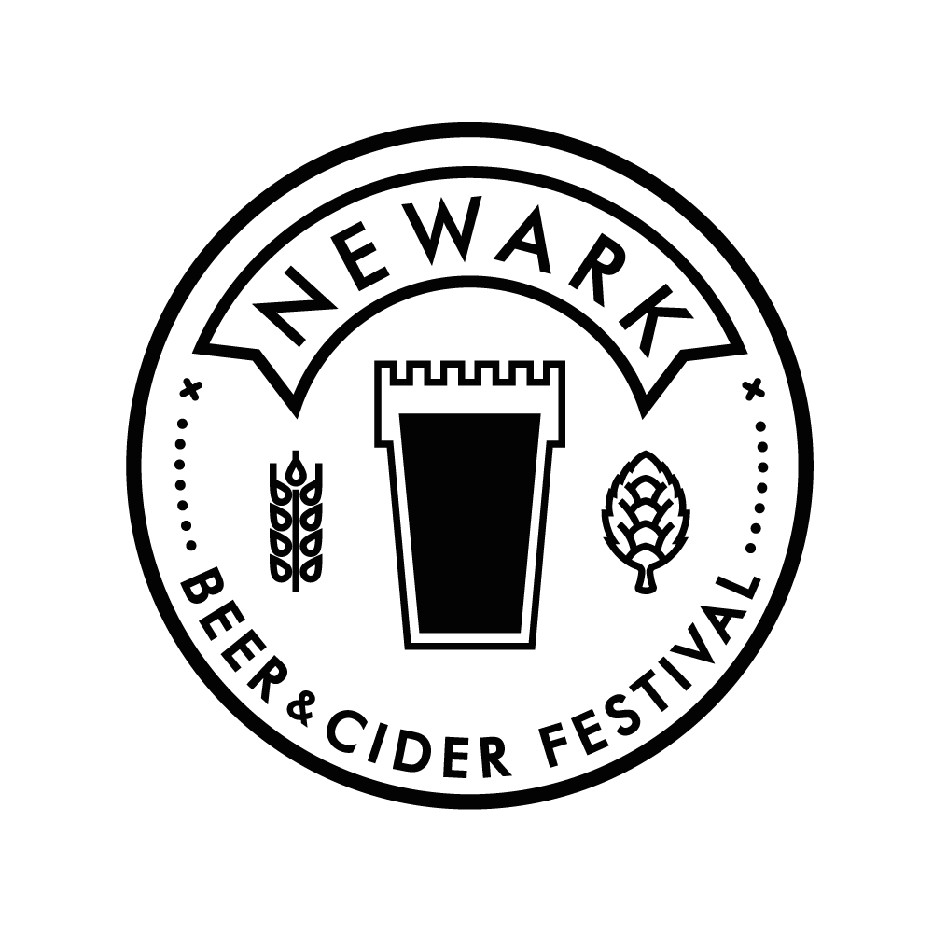

Shifts are allocated in blocks of 2 hours. This year we are asking for a minimum of 4 hours from you
which can be either one 4 hour slot or two different 2 hour slots across the festival.
Beer tokens will be allocated in the usual way – 3 tokens per 2 hours worked.
After a 4 hour block you will receive a food voucher (maximum 2 per day).

NAME:

EMAIL:

PHONE:

CAMRA MEMBERSHIP NO:

Have you volunteered at the Newark Beer Festival before: YES: NO:

Please mark x in the boxes below for the time and dates of the shifts you would like to do.

We also need help with the set up on Wed 22nd and Thur 23rd May. Please mark x if you can help with this.
WEDNESDAY 22/05 10am onwards – THURSDAY 23/05 10am onwards –
And lastly for the take-down on the afternoon of SUNDAY 26/05 –

PLEASE NOTE: ANYONE HELPING WITH SET UP AND TAKE DOWN MUST WEAR STEEL TOE-CAPPED FOOTWEAR. Newark CAMRA will subsidise £15.00 per person to purchase a pair.

SHIFT HOURS | FRI 24/05 | SAT 25/05
10:30 – 12:30
12:30 – 14:30
14:30 – 16:30
16:30 – 18:30
18:30 – 20:30
20:30 – 22:30

Are you willing to work anywhere? - Beer bar, Cider bar, Tokens, Door. YES: NO:

If not please state preferences:

PLEASE NOTE: BAR STAFF MUST WEAR ENCLOSED FOOTWEAR BEHIND THE BAR. SANDALS AND FLIP FLOPS WILL NOT BE ALLOWED.

We are planning to supply a free T-shirt to be worn whilst working.
Please mark x in the appropriate box for shirt size.

Small |  | Medium |  | Large |  | X Large |  | XX Large

Please email completed forms back to staffing@newarkcamra.org.uk
Or post to: 74 Harcourt Street, Newark NG24 1RF

Thank you

Sam Lucas (Beer Festival Volunteer Manager) 07967 204634

